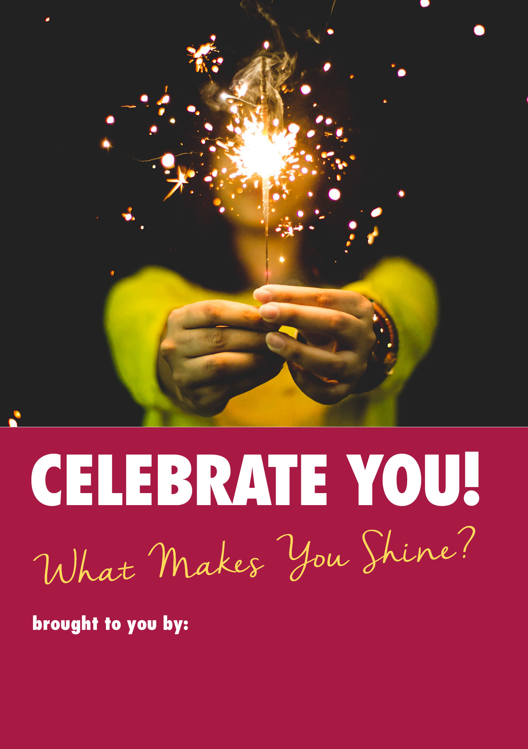

Your Business Name / Logo here
BACKGROUND: How do you shine? What gives you character? How are you a gem? This tool helps you appreciate yourself—in all your uniqueness and difference.

INSTRUCTIONS: Page 1
- Set aside 30 minutes to celebrate you! Find somewhere relaxing where you can sink into this exercise.
- Start by brainstorming your unique qualities, knowledge, skills and experiences below. Some tips:
• No judgement.There is no "good" or "bad" here, just the reality of you.
• Think broadly, loosely and from the heart.
• Include duplicates and similar items—these are good as it shows a theme or pattern!
• Include small things, big things, important things and "unimportant" things.
• Include what makes you different, unique—anything and everything that makes you YOU.
• Remember this isn't about what looks good to others, but what you like or are proud of in yourself.
- When the area is filled, circle the 10 items you're most proud of, or like most about yourself.
- Now for each of the 10 things you've circled, consider what strengths & qualities lie underneath eg. completing a marathon might represent courage, determination and focus. Write these extra qualities next to the item.

- Choose the one item you like most about yourself, and put a star next to it. Now turn over to page 2.

Here are some things to consider: Life experiences (positive and negative), healthy or helpful habits, challenges overcome, achievements, hobbies, skills and talents (however small or seemingly unimportant), qualities, your yearnings!, creations, how you make a difference in the world, your knowledge, what you do for fun—and what you get complimented for!

List everything that makes you unique below. How do you shine? What makes you a gem?

INSTRUCTIONS: Page 2
- Place the quality you starred (your favourite quality) in the centre of the heart below.
- Now copy across the remaining 9 qualities you circled (that you like most about yourself) into the gemstones below.
- Finally, answer the two questions at the bottom of this page to wrap up this exercise.
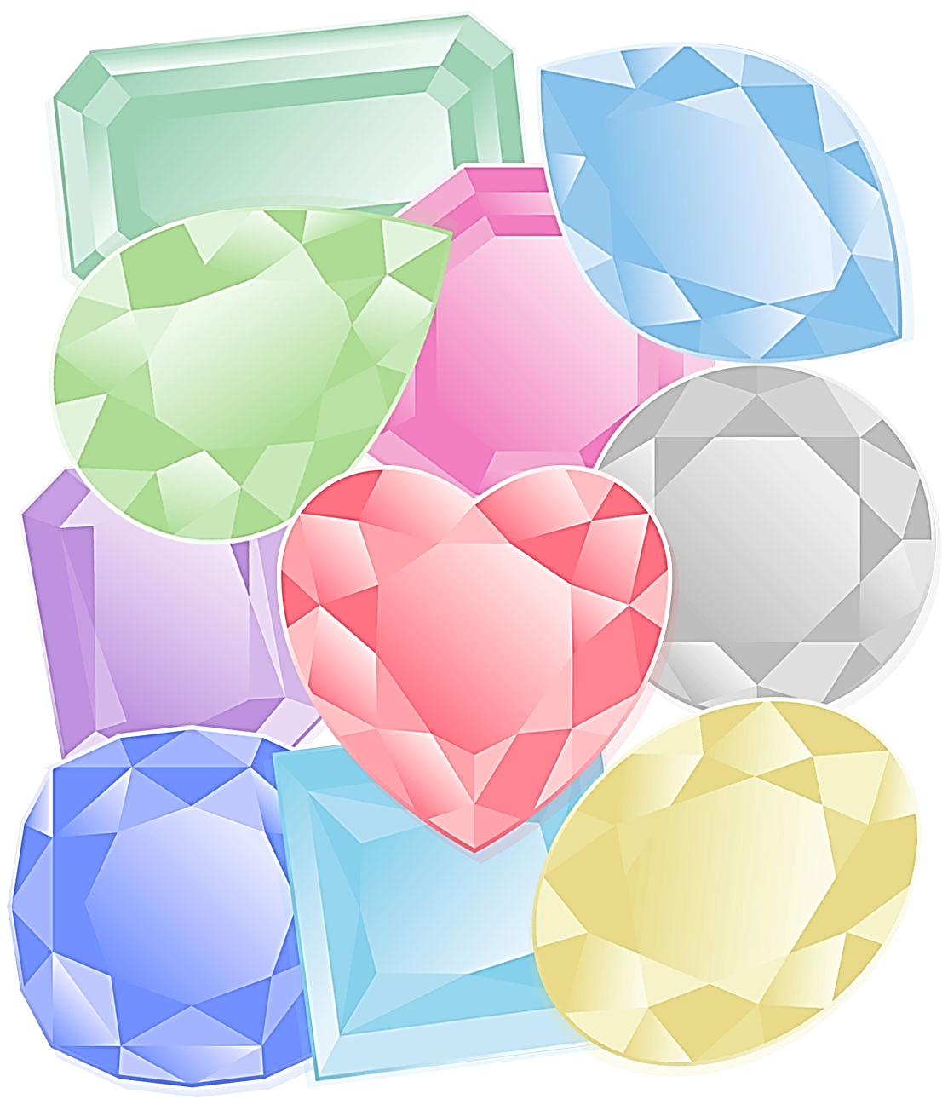

What have I learned from this exercise? ___________________________________________________
___________________________________________________________________________________

What new belief could I now create about myself and carry forward in life? ________________________
___________________________________________________________________________________

